Step 4.1 – Stellar Density
- Physics Concept:
Stars have mass and radius. The density of a star tells us how "compact" it is.

  - Mass is in solar masses.
  - Radius is in solar radii.
  - Volume of a sphere: V=43πR3V = \frac{4}{3} \pi R^3V=34​πR3

• Mass is in solar masses.
• Radius is in solar radii.
• Volume of a sphere:
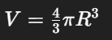
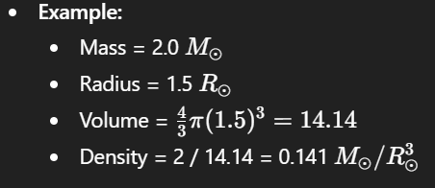

Step 4.2 – Planet Mass to Star Mass Ratio
- Physics Concept:
  - In exoplanet studies, the ratio of planet mass to star mass is important.
  - A planet much heavier than its star is rare; this helps detect extreme planets or errors.
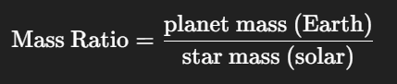


Step 4.3 – Log Transform for Skewed Features
- Why:
Some features, like stellar luminosity, are highly skewed (most stars are faint, few are very bright).
  - Log transform compresses high values and spreads low values → better for ML or plotting.
Physics:
- Star brightness varies millions of times → log makes it manageable


Step 4.4 – Planet Density Flag
- Physics Concept:
  - Planet density tells us composition:
    - 5 g/cm³ → rocky
    - <1 g/cm³ → gas giant
  - We can make a flag column to categorize planets.
Example:
- Planet density = 0.7 → gas_giant
- Planet density = 6 → rocky
- Planet density = 3 → intermediate

Step 4.5 – Planet Orbital Period in Years
- Physics Concept:
  - Some planets have very short or very long orbits. Converting days → years can make plots easier.
  - 1 year = 365.25 days
Example:
- Planet orbital period = 730 days → 730 / 365.25 ≈ 2 years

Step 4.6 – Semi-major Axis to Habitable Zone Check
- Physics Concept:
  - Habitable zone: distance from star where liquid water can exist.
  - Rough estimate using luminosity:
We can flag if planet is in the habitable zone.
AU stands for Astronomical Unit, and it is a standard unit of distance in astronomy.
- Definition:
1 AU ≈ the average distance between the Earth and the Sun.
- In numbers:
1 AU ≈ 149,597,870.7 km (about 150 million km)
Why 1.1 and 0.53 precisely?
The amount of energy a planet receives from a star (the stellar flux) decreases with distance squared:
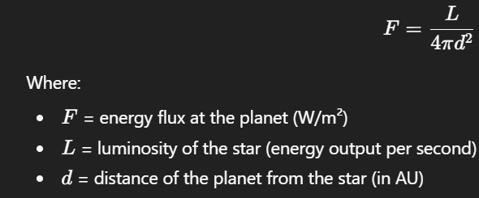
Link to Earth’s habitable zone:
- For Earth, the habitable zone is approximately 0.95 AU – 1.37 AU around a Sun-like star.
- More generally, scientists use empirical constants to calculate the inner and outer boundaries:
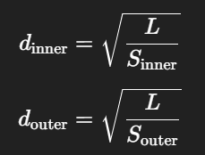
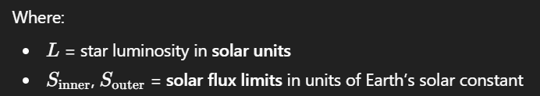
The 1.1 and 0.53 numbers:
- They are empirical constants from studies like Kopparapu et al. (2013), which define the conservative habitable zone limits:
  - Inner edge (too hot): 1.1
    - Planets closer than this get too much energy → too hot → water evaporates
  - Outer edge (too cold): 0.53
    - Planets farther than this get too little energy → too cold → water freezes
- So we divide the star’s luminosity by these numbers to scale the habitable zone for any star, not just the Sun.
We created new features from the original data:
- star_density_solar → how compact the star is
- planet_star_mass_ratio → planet mass relative to star
- star_luminosity_solar_log → scaled down luminosity
- planet_type → rocky, gaseous, or intermediate
- orbital_period_years → easier time unit for plotting
- in_habitable_zone → True/False

